Reading extract and questions:
Year 3-4
Forces
Set A/B

There are many ways to explain what a force is. Perhaps the simplest way to think of a force is as something that can make an object move from one position to another. If an object is not staying still, there is (or was) a force that caused that movement. What is more, the object will continue to move until there is another force working in the opposite direction.
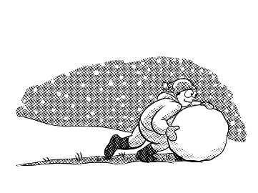
Many forces are very easy to spot. There are ones that involve pushing, like when you are rolling a giant snowball to make the body of a snowman. There are also ones that involve pulling, such as a team of huskies with a sledge. In both cases, you can clearly see who or what is doing all the work. It all depends on whether they are behind or in front of the object as it moves.
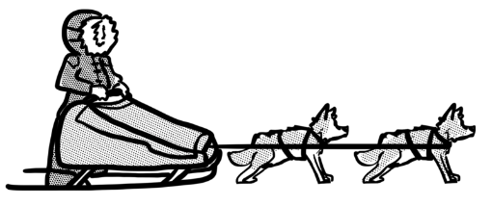

Pushing force Pulling force
There are, however, some forces that you cannot see at all. We don’t mean things like the wind in the sails of a boat – that force is invisible because we can’t see air, although we can still feel it. No, we’re talking about things like gravity – the force that pulls objects towards the centre of the Earth. You can’t see it. You can’t even feel it in the same way that you can sense the brush of the breeze through your hair. However, you will certainly know about it if you’ve ever lost your grip on the monkey bars!
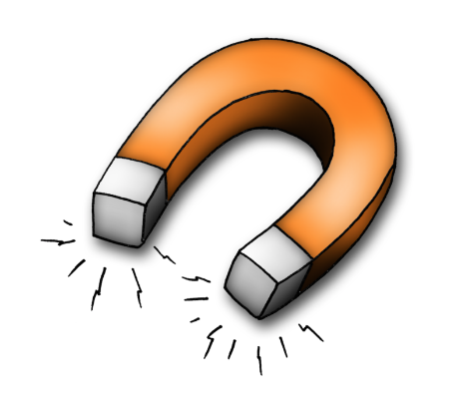
Magnetism is another force you can only notice by the effects it has on certain materials. It’s almost magic the way a magnet can pick up a nail, let alone the way it can still work through different materials. Have you ever seen iron filings moving around on a piece of card because there is a magnet shifting underneath?
If that’s hard to wrap your head around, magnetism can be both a pushing and a pulling force … at the same time! It all depends which end, or pole, of another magnet is closest. We call these opposite ends north and south. The north pole will attract the south pole of another magnet but repel the north.
So, if you have a magnet and you know which way round its poles are, you can also work out which is the north end and which is south of any other magnet, just by moving it close enough. The proof will be in the pudding, as they say … or rather the pushing or the pulling!

Questions for Forces Set A

Vocabulary:

1. Look at the first paragraph. Find and copy a word that means place.

_________________________________________________________________

2. … such as a team of huskies with a sledge … what are huskies?

_________________________________________________________________

3. The north pole will attract the south pole … Which group of words means the same as attract in this sentence? Tick one.

pull towards it push away from it

behave nicely to start a fight with

Retrieval
4. What does the text say that a force can do?

_________________________________________________________________

5. What was given as the example of a pushing force?

_________________________________________________________________

6. What are the two poles of a magnet called?

_________________________________________________________________

Inference
7. What does the text say is the main difference between pulling and pushing forces?

_________________________________________________________________

8. If we can’t see magnetism, how do we know about it?

_________________________________________________________________

9. If that’s hard to wrap your head around … Which group of words best explains what this means? Tick one.

If that feels like your skull … If you’re wearing a hat …

If that’s not easy to understand … If that makes you sad …

Summarise
10. Here are some summaries of different paragraphs in the text. Number them from 1 to 4 to show the order in which they appear in the text.

Some forces are invisible.
Magnetism is a force that only works on some materials.
Forces can push or pull.
Forces make things move.

_________________________________________________________________

Predict
11. What would gravity do to your body if you’ve ever lost your grip on the monkey bars?

_________________________________________________________________

Compare
12. Using what the text says, describe one way in which magnetism is

- Similar to other forces

_________________________________________________________________________________

_________________________________________________________________________________

- Different from other forces

_________________________________________________________________________________

_________________________________________________________________________________

Questions for Forces Set B

Vocabulary:

1. Look at the first paragraph. Find and copy a word that means carry on.

_________________________________________________________________

2. Look at the paragraph beginning Magnetism is another force … Which two words in the last sentence have the same meaning?

_________________________________________________________________

3. The north pole will … repel the north … Which group of words means the same as repel in this sentence? Tick one.

easily remember not like

pull towards push away

Retrieval
4. What does the text say will make an object stop moving?

_________________________________________________________________

5. What was given as the example of a pulling force?

_________________________________________________________________

6. Name two objects that the text says would be attracted to a magnet.

1. _________________________________ 2. __________________________________

Inference
7. What does the text suggest is unusual about the forces of gravity and magnetism?

_________________________________________________________________

8. It’s almost magic the way a magnet can pick up a nail … Explain why.

_________________________________________________________________

9. The proof will be in the pudding … Which group of words best explains what this means? Tick one.

You won’t know until you try. Puddings are magnetic.

You need to heat the magnets. The answer will be hidden.

Summarise
10. Using the whole text, tick one box in each row to show whether each statement is true or false.

 | True | False
All forces are easy to see.
Magnetism can be blocked by paper or card.
The north pole of one magnet will pull towards the south pole of another.

Authorial intent
11. … the brush of the breeze through your hair … Explain why the word brush was used.

_________________________________________________________________________________

_________________________________________________________________________________

Compare
12. How are gravity and magnetism...

- Different from each other?

________________________________________________________________________

- Similar to each other?

________________________________________________________________________

Answers for Forces
Set A:

Vocabulary:
1. position
2. (breed of) dogs
3. pull towards it
Retrieval:
4. make an object move (from one position to another)
5. rolling a giant snowball
6. north and south
Inference:
7. whether it is acting in front of or behind the object as it moves
8. You can see its effects on other materials.
9. If that’s not easy to understand …
Summarise:
10.

3 Some forces are invisible.
4 Magnetism is a force that only works on some materials.
2 Forces can push or pull.
1 Forces make things move.

Predict:
11. It would pull you down to the ground./You would fall down.
Compare:
12.
- It can make objects move. It can be a pulling or a pushing force.
- It can’t be seen. It doesn’t work on all materials.

Commissioned by The PiXL Club Ltd. July 2019
This resource is strictly for the use of member schools for as long as they remain members of The PiXL Club. It may not be copied, sold nor transferred to a third party or used by the school after membership ceases. Until such time it may be freely used within the member school.
All opinions and contributions are those of the authors. The contents of this resource are not connected with nor endorsed by any other company, organisation or institution.
PiXL Club Ltd endeavour to trace and contact copyright owners. If there are any inadvertent omissions or errors in the acknowledgements or usage, this is unintended and PiXL will remedy these on written notification.

© Copyright The PiXL Club Limited, 2019
Answers for Forces
Set B:

Vocabulary:
1. continue
2. moving and shifting
3. push away
Retrieval:
4. when another force acts in the opposite direction
5. huskies pulling a sledge
6. pick two from: nail/iron filings/other magnets
Inference:
7. You can’t see them.
8. It looks like a trick./It seems amazing./You can’t see how it’s being done.
9. You won’t know until you try.
Summarise:
10.
 | True | False
All forces are easy to see. |  | √
Magnetism can be blocked by paper or card. |  | √
The north pole of one magnet will pull towards the south pole of another. | √

Authorial intent:
11. Like a brush, the wind is passing through your hair./It is gentle like a hairbrush.
Compare:
12.
- Gravity pulls things down, magnets can pull things in different directions
- They can both pull things/have a pull force

Commissioned by The PiXL Club Ltd. July 2019
This resource is strictly for the use of member schools for as long as they remain members of The PiXL Club. It may not be copied, sold nor transferred to a third party or used by the school after membership ceases. Until such time it may be freely used within the member school.
All opinions and contributions are those of the authors. The contents of this resource are not connected with nor endorsed by any other company, organisation or institution.
PiXL Club Ltd endeavour to trace and contact copyright owners. If there are any inadvertent omissions or errors in the acknowledgements or usage, this is unintended and PiXL will remedy these on written notification.

© Copyright The PiXL Club Limited, 2019

