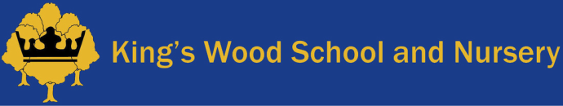

Home Learning Spring 2 2020

Dear Parents
This term our topic is ‘Vincent Van Gogh’.
Our learning will be focusing on:
- History, Art and Science
- Non-fiction texts
- Labelling diagrams
- Plants: seeds and how plants grow.
- Poetry

Listed below are some suggested activities that you may like to try at home as part of your child’s home learning:
Observation drawings, photos of plants/flowers in the environment.
Label parts of a plant
Discuss what plants need in order to grow
Useful website: BBC Bitesize-Science: Plants
Plant some seeds and keep a diary of growth - can you measure how much it grows each week?
Match seeds to their plant/fruit
Write instructions with pictures/photos ‘How to plant a seed’.
Science experiment: Plant some seeds in yogurt pots using different materials and in different places.
Which ones grew the most and why? Record how they grow. You could put some seeds in soil, cotton wool or kitchen towel. Think about planting them in a cool dark place, a warm bright place, with or without water.

Useful website: BBC Bitesize- Plants
Visit a garden centre and look at the different types of plants and their names.
Visit an Art Museum or local art exhibition.

