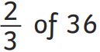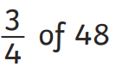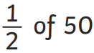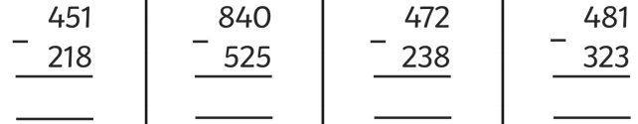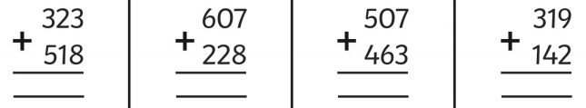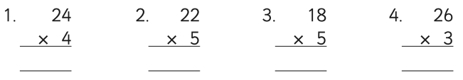

4.36 x 10 =

54.56 x 10 =

1.289 x 100=

98.34 ÷ 10 =

986.4 ÷ 100 =