Year 4 W1c skills test 3

Child as a writer – Can generate multiple feasible ideas from a stimulus

Commissioned by The PiXL Club Ltd.
May 2018
This resource is strictly for the use of member schools for as long as they remain members of The PiXL Club. It may not be copied, sold nor transferred to a third party or used by the school after membership ceases. Until such time it may be freely used within the member school.
All opinions and contributions are those of the authors. The contents of this resource are not connected with nor endorsed by any other company, organisation or institution.
PiXL Club Ltd endeavour to trace and contact copyright owners. If there are any inadvertent omissions or errors in the acknowledgements or usage, this is unintended and PiXL will remedy these on written notification.

© Copyright The PiXL Club Limited, 2018
W1c – Child as a writer
Can generate multiple feasible ideas from a stimulus
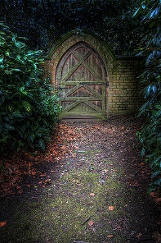

Look at this picture.

- Using the picture as a stimulus, write brief notes about three different ideas for a story.

Idea 3 ____________________________________________________________________
___________________________________________________________________________

Idea 2 ____________________________________________________________________
___________________________________________________________________________

Idea 1 ____________________________________________________________________
___________________________________________________________________________

- Choose your favourite idea, then write more notes to suggest how you could develop it in more detail.
___________________________________________________________________________

_____________________________________________________________________

_____________________________________________________________________

