Flaming extension work

WWII: WAR IN JAPAN

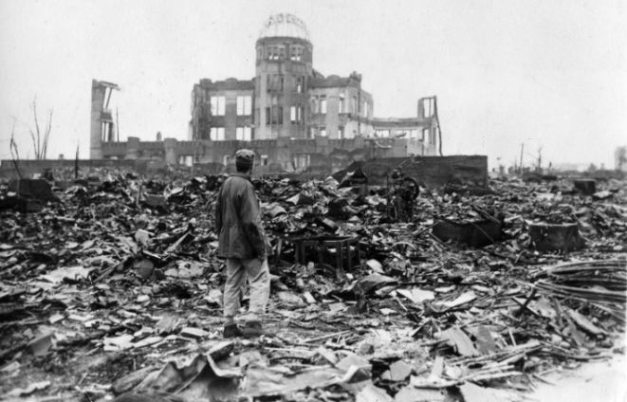

Look at the PowerPoint about Hiroshima (there are no horrific images).
Use the internet to investigate:
- The bombing of Pearl Harbour.
- The war from USA and Japanese point of view.
- The Japanese belief in no surrender.
- Japanese concentration camps containing allied soldiers. How prisoners were treated and why.
- The reasons for the USA dropping the atomic bomb (to speed up the end of the war) versus the Japanese civilians this killed.

Suitable websites:
https://www.ducksters.com/history/world_war_ii/pearl_harbor_attack.php
https://www.bbc.co.uk/news/magazine-33931660
https://www.youtube.com/watch?v=ya3et3mhdWw

Task to show understanding and to use skills learnt in Mrs Virgo and Miss Kirk’s English groups: write a balanced argument, outlining why the atom bombs should/ should not have been dropped and why.

Remember, a balanced argument should include an introduction, paragraphs for and against, and a conclusion where you weigh up the main points from each side of the argument and give your overall opinion.

After watching the YouTube animated film link above, you might also be inspired to write a poem.

If you are proud of your work, type it in Word and email to the school office:
office@kingswood.bucks.sch.uk
Remember to put ‘FAO Miss Kirk’ in the message title.

