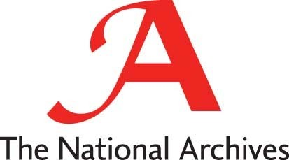
Education Service

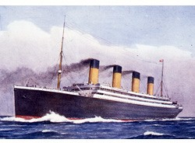

The sinking of the Titanic, 1912
Who was on board?

Introduction
The Titanic was built at a cost of around £1.5 million, in Belfast, for the White Star shipping line. She was the largest passenger steamer of her day, at over 46,000 tons, and supposedly the most up to date. Special watertight compartments made her "practically unsinkable", claimed the owners. They also advertised the luxurious First Class accommodation, with large state-rooms, a Parisian café, a swimming pool and restaurant. She set sail from Southampton on her maiden voyage on Wednesday, April 10th, 1912, calling at Cherbourg in France and Queenstown in southern Ireland before heading out across the Atlantic, on course for New York. Late on the night of Sunday April 14th she struck an iceberg and was holed below the waterline. Less than three hours later she sank. Only 705 people were rescued from over 2,200 on board.
The first ship to cross the Atlantic by steam power alone was the Sirius, in 1838, taking 18 days to make the journey. However, early iron steamships were inefficient and the next fifty years saw the last flowering of ocean-going sailing vessels. Only the invention of the steam turbine in 1884 and production of cheap steel enabled steam to overtake sail at last. In the opening years of the 20th century a new design of vessel, the "liner" appeared. They were much bigger and faster, with more carrying capacity: the Mauretania crossed the Atlantic in less than five days in 1907. More space meant more room for passengers to travel in luxury and, until air travel superceded them in the 1950s, the Atlantic liner was the last word in comfortable, speedy travel. The publicity given to the quality of First Class accommodation on the Titanic was therefore typical.
Throughout the 19th century millions of Europeans left the continent for new lands in Australia, South America, Africa and, especially, North America. The peak was reached in the first decade of the 20th century, when 11 million Europeans crossed the Atlantic to settle in the USA, 3.2 million of them from the UK and Ireland. Not surprisingly, emigrants were usually poor: one of their main reasons for emigrating was to build a better life in America, which was seen as a "land of opportunity". Back in the 19th century, shipowners had crammed emigrants below decks with inadequate facilities in order to keep fares low. The White Star Line, ironically, was one of the first to offer decent, although still cheap, accommodation to emigrant passengers.
The sinking of the Titanic with the loss of 1500 lives caused an uproar on both sides of the Atlantic. Newspapers blamed the owners for inadequate safety arrangements. Others blamed the captain for going too fast and too carelessly in waters known to be iceberg-infested.
An enquiry in the US Senate fixed on the fact that there were not enough lifeboats for the number of passengers, although the owners certainly provided more than they were required to by law at the time. It was also pointed out that not all the lifeboats that were on board could be launched in the time it took to sink. Many passengers anyway refused to get into the lifeboats, some of which left the ship half full.
Safety regulations had not caught up with these new massive liners and were rapidly changed. A new regulation of 1913 required all vessels to carry enough lifeboats for every passenger. An iceberg patrol was set up by the US Coastguard.

Source 1 : Extract from the list of passengers drowned: First Class passengers. (BT 100/260)
U.S.C. = United States Citizen

Thomas Andrews was the designer of the TITANIC; Colonel JJ Astor was one of the richest men in the world, worth over £20 million; Major Butt was an adviser to the US President Taft.
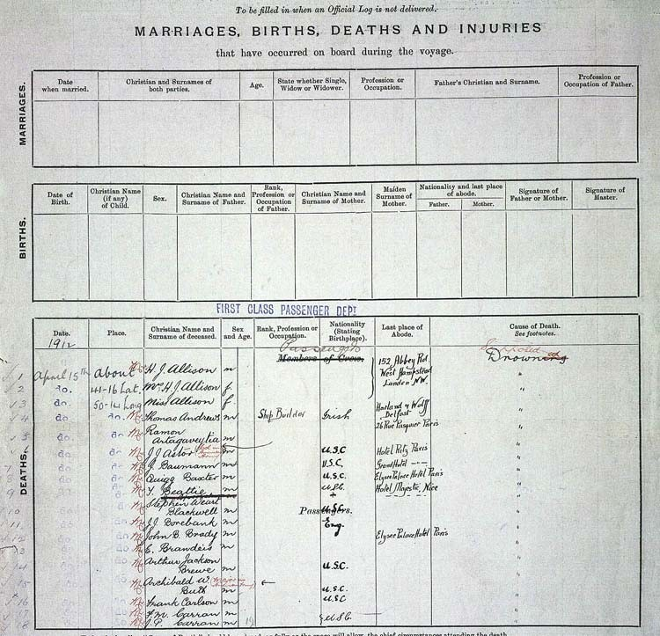

Source 1 : Transcript of Extract from the list of passengers drowned: First Class passengers. (BT 100/260)
To be filled in when an Official Log is not delivered
DEATHS.
MARRIAGES, BIRTHS, DEATHS AND INJURIES
that have occurred on board during the voyage
MARRIAGES.
Date when married. | Christian and Surnames of both parties | Age | State  whether Single, Widow or Widower | sion or occu | Fathers Christian and Surname | Profession or Occupation of Father

Date of Birth | Christian Name (if any) of Child | Sex | Christian Name and surname of Father | Rank, Professio n or Occupatio n of Father | Christian Name and Surname of Mother | Maden Surname of Mother | Nationality and last place of abode |  | Signature of Father or Mother | Signature of Master
 |  |  |  |  |  |  | Father | Mother

FIRST CLASS PASSENGER DEPT
BIRTHS.
Date | Place | Christian Name and Surname of deceased | Sex and age |  | Rank, profession or  occupation | Nationalit y (Stating Birthplace  ) | Last Place of Abode | Cause of Death
April 15th | about | Mr H.J. Allison | M |  | Members |  | 152 Abbey Rd | Suspected Drowning
do | 14-16 Lat | Mrs H.J. Allison | F |  | of Crew |  | West Hampstead | "
do | 50-14 Lon | Miss Allison | F |  |  |  | London NW | "
do | do | Mr Thomas Andrews | M |  | Shipbuilder | Irish |  | "
do | do | Mr Ramon | M |  |  |  | Harland & Wolff | "
 |  | Antagavetia |  |  |  |  | Belfast | "
do | do | Mr JJ Astor (Col in | M |  |  | U.S.C. | 26 Rue Pasquier | "
 |  | American Army) |  |  |  | U.S.C. | Paris | "
do | do | Mr J Baumann | M |  |  | U.S.C. |  | "
do | do | Mr Quigg Baxter | M |  |  | U.S.C. | Hotel Ritz Paris | "
do | do | Mr J Beattie | M |  |  | + | Grand Hotel -~- | "
do | do | Mr Stephen Weast | M |  |  | U.S.C. | Elysee Palace | "
 |  | Blackwell |  |  |  |  | Hotel Parts | "
do | do | Mr JJ Borebank | M |  |  | Eng | Hotel Majestic | "
do | do | Mr John B Brady | M |  |  |  | Nice | "
do | do | Mr E Brandeis | M |  |  | U.S.C. | -~- -~- -~- | "
do | do | Mr Arthur Jackson | M |  |  | U.S.C. |  | "
 |  | Brewe |  |  |  |  | Elysee Palace | "
do | do | Mr Archibald W Buth | M |  |  | U.S.C. | Hotel Paris | "
 |  | (Major in American |  |  |  |  |  | "
 |  | Army) |  |  |  |  |  | "
do | do | Mr Frank Carlson | M |  |  |  |  | "
do | do | Mr F.M. Carran | M |  |  | U.S.C. |  | "
do | do | Mr J.P.Carran | M |  |  | U.S.C. |  | "

Source 2 : Extract from the list of passengers drowned: Third class passengers. (BT 100/260)

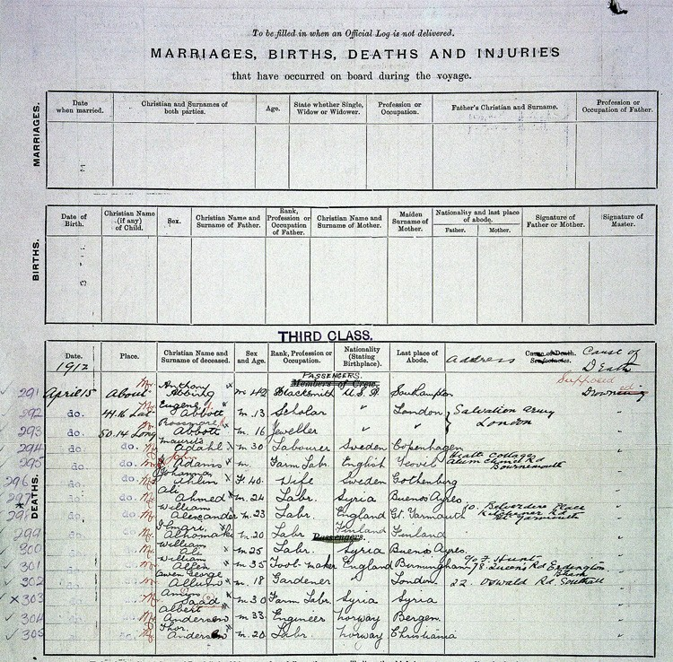

Source 2 : Transcript of Extract from the list of passengers drowned: Third class passengers. (BT 100/260)
To be filled in when an Official Log is not delivered
MARRIAGES, BIRTHS, DEATHS AND INJURIES
that have occurred on board during the voyage
MARRIAGES.
Date when married. | Christian and Surnames of both parties | Age | State  whether Single, Widow or Widower | sion or occu | Fathers Christian and Surname | Profession or Occupation of Father

Date of Birth | Christian Name (if any) of Child | Sex | Christian Name and surname of Father | Rank, Professio n or Occupatio n of Father | Christian Name and Surname of Mother | Maden Surname of Mother | Nationality and last place of abode |  | Signature of Father or Mother | Signature of Master
 |  |  |  |  |  |  | Father | Mother

THIRD CLASS
DEATHS.
BIRTHS.
Date | Place | Christian Name and Surname of deceased | Sex and age |  | Rank,  profession or occupation | Nationalit  y (Stating Birthplace  ) | Last Place of Abode | Address | Cause of Death
April 15th | about | Mr Eugene Abbott | M | 42 | Scholar | U.S.A | Southampton | Army, London | Supposed
do | 14-16 Lat | Mr Rossmare Abbott | M | 13 | Jeweller | " | London | Heath | Drowned
do | 50-14 Lon | Mr Maurits Adahl | M | 16 | Labourer | " | " | Cottage Alum | "
do | do | Mr John Adams | M | 30 | Farm Lab | Sweden | Copenhagen | Chanel Rd | "
do | do | Mrs Johanna Ahlem | M |  | Wife | English | Yeovil | Bournemouth | "
do | do | Mr Ali Ahmed | F | 40 | Lab[oure]r | Sweden | Gothenberg | 10 Belverdere | "
do | do | Mr William | M | 24 | Lab[oure]r | Syria | Buenos Aires | Place | "
do | do | Alexander | M | 23 | Lab[oure]r | England | Gt Yarmouth | Kitchener | "
do | do | Mr Ali Imari Alhamaki | M | 20 | Lab[oure]r | Finland | Finland | Road Gt | "
do | do | Mr William Ali | M | 25 | Tool- | Syria | Buenos Aires | Yarmouth | "
do | do | Mr William Allen | M | 35 | Maker | England | Birmingham | c/o F Hunt 78 | "
do | do | Mr Owen George | M | 18 | Gardener |  | London | Queens Road | "
 |  | Allum |  |  |  |  |  | Erdington
do | do | Mr Amiro Saad | M | 30 | Farm Lab | Syria | Syria | B'ham | "
do | do | Mr Albert Anderson | M | 33 | Engineer | Norway | Bergen | 22 Oswald Rd | "
do | do | Mr Thomas | M | 20 | Lab[oure]r | Norway | Christiana [Oslo] | Southall | "

Source 3a : First Class Suite Bedroom 'B58' (Ulster Folk and Transport Museum)
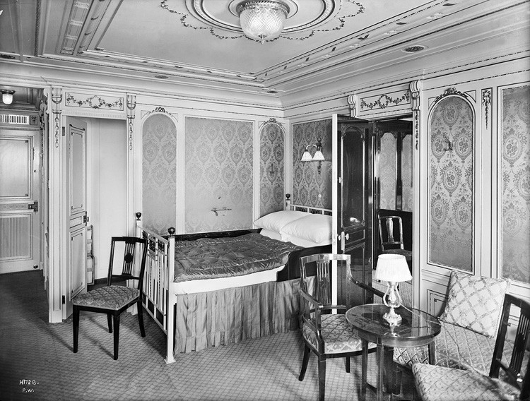

Source 3b : Third Class berth (Ulster Folk and Transport Museum)
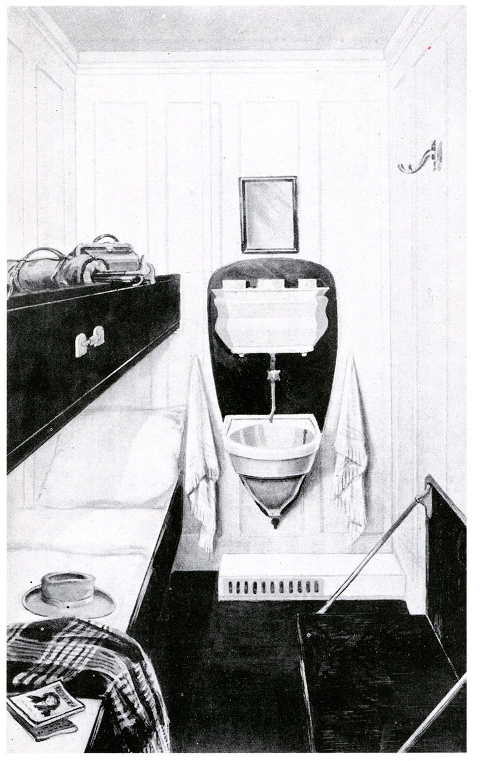

Source 4 : Survey of an Emigrant Ship: Certificate of Clearance (MT 9/920f)
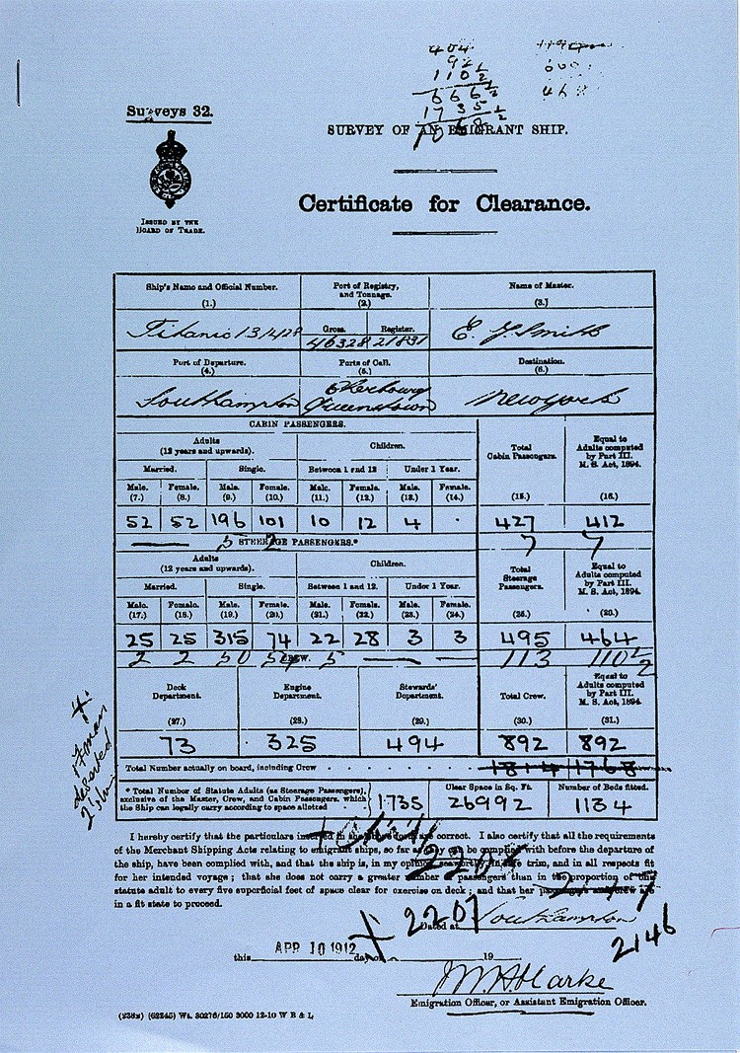

Source 4 : Transcript of Survey of an Emigrant Ship: Certificate of Clearance (MT 9/920f)
This is a very simplified transcript of the document MT 9/960f. "Cabin passengers" were First or Second Class passengers.
"Steerage" passengers were in Third Class berths or slept in open rooms.
Port of embarkation | Number of cabin passengers embarked | Number of steerage passengers embarked | Crew
Southampton | 427 (26 children) | 495 (56 chidren) | 892
Cherbourg | 172 (5 children) | 102 (17 children) | 892
Queenstown | 7 (0 children) | 113 (5 children) | (7  deserted)
Total | 606 (31 children) | 710 (78 children) | 885

Source 5 : Telegram received by the Russian liner Birma (MT 9/920c)
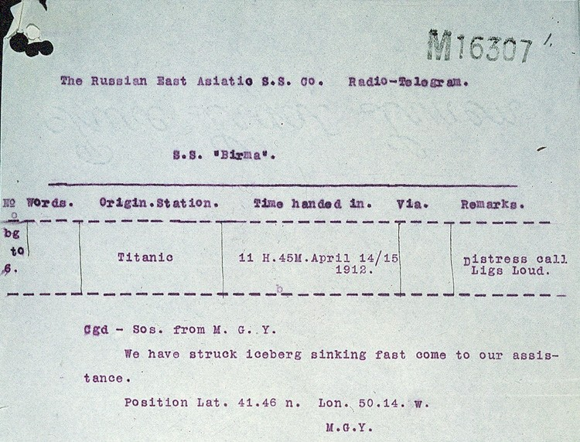

Source 5 : Transcript of Telegram received by the Russian liner Birma (MT 9/920c)
The Russian East Asiatic S.S. Co. Radio-Telegram

S.S. "Birma"

No Words Origin Station. Time handed in.
Via. Remarks
bg to 6. | Titanic | 11 H.45M.April 14/15 1912. |  | Distress Call Ligs Loud
Cgd - SOS. from M. G. Y.
We have struck iceberg sinking fast come to our assistance. Position Lat. 41.46 n. Lon. 50.14. W.
M. G. Y.

(MGY was the codename for the TITANIC)

Tasks
Look at Source 1

- This is a list of passengers who were killed in the sinking.

  - What clues are there from this list that this is the First Class passenger list, not the Third?
  - Most of the people on this list do not have an occupation listed, why do you think this is?
  - This list shows HJ Allison, his wife and his daughter. We know that JJ Astor travelled with his wife Madeline, but she is not listed beside him. Why do you think this is?

Look at Source 2

- This is also a list of passengers killed in the sinking

  - What countries have these people come from?
  - How many different occupations are there listed?
  - What other differences can you see between the 1st and 3rd class lists? Why do you think this is?

Look at Source 3 a & b

- These are images of the Titanics cabins in 1st and 3rd class:

  - Compare the two types of accommodation shown here. Write three sentences to describe the differences.
  - What does this tell you about differences between rich and poor at that time?
  - Which of these cabins would you have preferred to stay in? Give your reasons why.

Look at Source 4

- This is a page from a document headed "Survey of an Emigrant Ship: Certificate of Clearance". Use the simplified transcript to answer the questions below.

  - Where did most people embark?
  - Which class of passenger made up the majority of those embarking at Cherbourg?
  - Which class of passenger made up the majority of those embarking at Queenstown?
  - Which class of passenger were in a majority of all those on board when the TITANIC set off for New York?
  - Look at the title of the document on which the table is based. What does this tell you about who all these steerage passengers were?

Look at Source 5

- This is a telegram received by the Russian liner Birma

  - When was it received?
  - If you were the wireless operator on the BIRMA, how would you report this message to the Captain?
  - If you were the Captain of the BIRMA, what would you do?

- The Titanic has the reputation of being a luxury ship. Is this reputation justified?

- 7. 705 of those on board the Titanic when she struck the iceberg survived. Of the survivors:

- 381 were cabin class passengers, including all the children in this class,
- 270 were steerage passengers, including 26 of the children in this class,
- 52 were crew.

- What does this tell you about the safety arrangements for different types of passengers?

