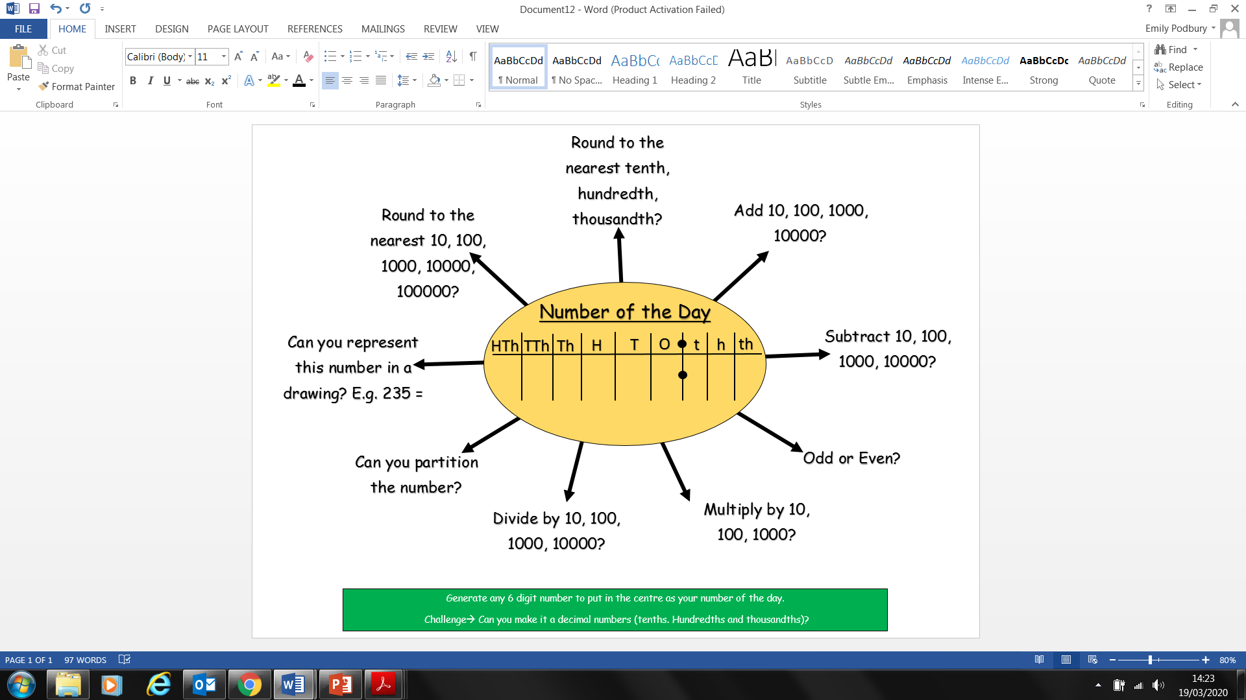

Can you represent this number in a drawing? E.g. 235 =

Can you partition the number?

Divide by 10, 100, 1000, 10000?

Multiply by 10, 100, 1000?

Odd or Even?

Subtract 10, 100, 1000, 10000?

Add 10, 100, 1000, 10000?

Round to the nearest tenth, hundredth, thousandth?

Round to the nearest 10, 100, 1000, 10000, 100000?

HTh

Number of the Day

TTh

Th

H

T

O

t

h

th

Generate any 6 digit number to put in the centre as your number of the day.

Challenge🡪 Can you make it a decimal numbers (tenths. Hundredths and thousandths)?